ASSIGNMENT 3: “THE MAZE”

Navigating A Robot Through A Maze

Download the file Maze.java from the course website. You should also read the other documents associated with this assignment (guides and rubrics) before you start working on it.

You should add code to the NavigateMaze command to make the robot go from the starting point to the end point.

The only things which you may assume about the maze are the following: with the exception of the entry point and exit point, the outer wall of the maze will be unbroken (so you don't have to worry about the robot wandering out of the maze by going through the 'wrong door out').

You may also assume that the maze will be configured so that the MazeBot will start in between 2 walls, and will be pointing into the maze (i.e., there will be a wall on its left, and a wall on it's right).

You're also guaranteed that there actually is a way to get through the maze to the exit point.

You're not allowed to leave the maze (by turning 180 degrees around, and leaving via the entry point), walk around the maze to the exit point, and pronounce yourself done.

Thus, the Maze.java file gives a single maze that your robot should be able to navigate through, but this isn't the only maze—any maze that satisfies the limitations set forth in the prior paragraph should be something that your robot can handle.

THIS MEANS YOUR ROBOT SHOULD BE ABLE TO SUCCESSFULLY NAVIGATE ANY MAZE AS LONG AS ITS END POINT COORDINATES ARE THE SAME (AVENUE 9 and STREET 10).

As such, you cannot just give it a “hard-coded’ set of directions like "move forwards 9 times, turn right once, move twice, etc."

I WILL BE TESTING YOUR CODE IN A SLIGHTLY DIFFERENT MAZE THEN THE ONE YOU ARE USING (IN TRUTH, I’LL BE ADDING ADDITIONAL WALLS AND BLIND ALLEYS TO THE SUPPLIED MAZE TO DETERMINE WHETHER YOUR ROBOT CAN SUCCESSFULLY MAKE ITS WAY THROUGH IT WITH THESE NEW FEATURES). IF YOUR ROBOT CRASHES WITH THESE NEW FEATURES YOU WILL LOSE POINTS.

A picture of one possible maze is given below:

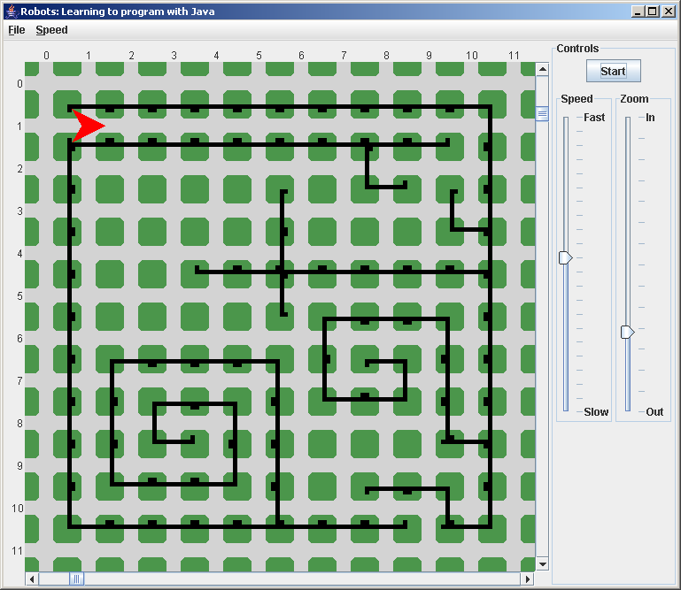

Additionally, each MazeBot should also start with exactly 1,000 Things in its backpack. Each time the MazeBot moves forwards, it should leave a Thing in the current intersection, but only if there isn't a Thing there already. Obviously, the robot shouldn’t break if it runs out of Things (regardless of whether there’s something in the intersection or not). This means the robot would successfully finish the Maze even if it ran out of things in its backpack (you might use the countThingsInBackback() method in some logical way to determine whether or not to lay a Thing down).

I WILL BE TESTING YOUR CODE WITH THE ORIGINAL NUMBER OF 100 THINGS IN THE BACKBACK AND ALSO BY CHANGING THIS NUMBER TO ‘10’ AND ALSO TO ‘0’ TO DETERMINE WHETHER THE ROBOT WILL SUCCESSFULLY NAVIGATE THE MAZE REGARDLESS OF THE NUMBER OF THINGS IN ITS BACKPACK (WHETHER 100, 10, or 0). THE ROBOT WILL LAY THINGS CORRECTLY IF IT HAS THEM TO PUT DOWN, AND WILL STILL FINISH THE MAZE IF IT DOES NOT. IF THE ROBOT CRASHES DURING THIS THING TEST YOU WILL LOSE POINTS.

The MazeBot also needs to be able to print the total number of spaces it has moved, via a new method named printTotalNumberOfSpacesMoved. This will print the total number of spaces that the MazeBot has moved since the NavigateMaze method was called. In other words, if someone calls NavigateMaze on the MazeBot, and it takes 15 moves to move through the maze, then printTotalNumberOfSpacesMoved should print that it took 15 spaces.

An outline of this method is provided in the Maze.java file.

Likewise, you will need to print out how many times the robot moved facing East, South, West, and North during its journey through the Maze. You might want to add methods that will tell someone how many spaces the robot has moved while facing east (name this printTotalNumberOfSpacesMovedEast), another for the number of spaces moved while facing west (name this printTotalNumberOfSpacesMovedWest), another for the number of spaces moved while facing north, and one last for the number of spaces moved while facing south. Much like the plain-vanilla printTotalNumberOfSpacesMoved, these methods only record the total number of spaces moved (in their respective directions) since the last time the MazeBot was told to NavigateMaze. If you prefer you could do all this in a single method instead called printEverything which would print the total number of spaces moved and how many times it moved facing East, South, West, and North to the human user. Make sure that whenever NavigateMaze finishes navigating its way through a maze, this new command is called.

AT A MINIMUM, ONCE THE ROBOT SUCCESSFULLY MAKES ITS WAY TO THE END OF THE MAZE, YOUR PROGRAM WILL NEED TO PRINT OUT THE CORRECT COUNT FOR EACH OF THE FOLLOWING:

- TOTAL NUMBER OF MOVES MADE
- NUMBER OF TIMES MOVED EAST
- NUMBER OF TIMES MOVED SOUTH
- NUMBER OF TIMES MOVED WEST
- NUMBER OF TIMES MOVED NORTH

IF YOU FAIL TO INCLUDE THIS PRINT OUT OR SHOW INCORRECT VALUES, YOU WILL LOSE POINTS.

You should put your answer to this part of the homework assignment in a file named Maze.java.

Team Work

You will work with 2-3 other people on this homework assignment. Working together with other people should help you overcome conceptually minor technical difficulties, and will allow you to discuss strategies and tactics about how to solve the problem.

You are required to hand in just one assignment for the entire group. An identical grade will be given to all group members, although the instructor reserves the right to modify that grade if subsequent information indicates people didn't contribute equally.

In particular, the instructor reserves the right to assess the extent of learning via such methods as verbal questioning, quizzes (announced or otherwise), etc. The purpose of having you work in groups is to ensure that you each develop a thorough understanding of how to program; it is NOT to make one person do all the work. Your have been assigned to a group by your professor. Find your Assignment 3 Group under the People section for our course in Canvas.

You are required to provide your team partner(s) with at least 2 means of contact – a gmail/yahoo/hotmail email account that you check regularly and your cell phone number would be fine. You could even create a brand new account/number just for this class, or even just for this assignment. Likewise, you do need to be responsive, and collaboratively work towards the completion of the assignment. During class you and your partners must schedule a 2-hour (or longer) meeting outside of class.
Do not divide up the work for this assignment, but instead use the meeting to collaborate and discuss solutions and strategies together while taking turns typing on 1 computer (or use the Conferences tool in Canvas for screen-sharing).

Documentation

Make sure that every file contains the names of all team members, as well as the class name, year and quarter. For your Java files, put these in comments at the top of the file.

The team should also produce a short, two page (maximum!) single-spaced document describing how the program works. I want to see concise, yet insightful, and helpful explanations of each of the methods or algorithms that make up the program (in particular, you should include a description of the method or algorithm for finding a way through the maze, for dropping Things, for tracking the total number of spaces moved). Additionally, you'll need to provide a quick overview of how each of these methods or algorithms interact to solve the overall problem.

There is no minimum length—if you can explain how the maze algorithms work in less than 2 pages feel free to do so (for example, your explanation is clear, and only ½ of a page, that's fine).

IF YOU FAIL TO INCLUDE THIS SHORT SUMMARY DOCUMENTATION, YOU WILL LOSE POINTS.

What to Turn In:

Make sure your group turns in this assignment by the due date and time, because other groups will evaluate it using the rubrics. Turning this assignment in late could mean you miss out on that feedback, and thus your group will be at a disadvantage when it come to revisions.

- Submit to the Java Code Critic Module, under the “Assignment 3” exercise, all of the code from Maze.java. Only one person in the group should do this, but when your professor grades it, that person must distribute print outs (or export to PDF and distribute a file) of the critiques of the code to the other group members.
- Submit to the Canvas “Assignment 3” a single electronic zipped folder file whose name contains the last names of all group members, and the homework number (A3). Only one person in the associated Canvas group needs to do this (Canvas will assign the same grade to everyone in he group and everyone in the group will see any Canvas-based feedback). This folder must contain:-【
  - Maze.java.
  - MazeBot.doc/docx/odt/rtf
  - Any other files that you feel ought to be included.
- Example: Let's say that Ada Hopper, Buck Pinkus, and Rex Winkus are working together on this project. The zipped folder file would be named something like:
"Hopper-Pinkus-Winkus-A3.zip" and contain the above files. Make sure there are no spaces in the folder's name and the zip archives's filename.
- All of the non-Java files need to be provided in Microsoft Word, Libre/Open Office, or RTF format. Your professor will also accept PDF files as well (both Mac word-processing software and Open/Libre Office can export to PDF).
- Make sure that everyone’s names are in the Java files and in the MazeBot document.

